**PFP - Labwork 05**

**Q1 (2.5 marks).** **Write a program that performs the following tasks:**

1. Write a function in Python to read the content from a text file "poem.txt" line by line and display the same on-screen.

**Expected Output:**



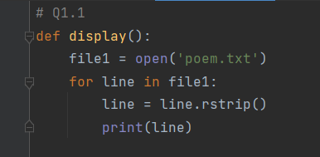

1. Write a function in Python to count the number of lines from a text file "story.txt," which is not starting with an alphabet "T."

Example: If the file "story.txt" contains the following lines:

A boy is playing there.  
There is a playground.  
An airplane is in the sky.  
The sky is pink.

**Expected Output:**



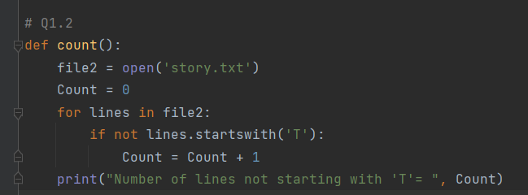

**Q2** **(2.5 marks). Write a program that performs the following tasks:**

1. Write a function in Python to count and display the total number of words in a text file.

**Expected Output:**



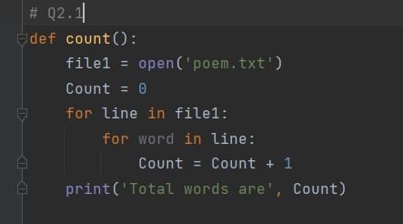

1. Write a function display_words() in Python to read lines from a text file "story.txt" and display those words less than 4 characters.

**Expected Output:**



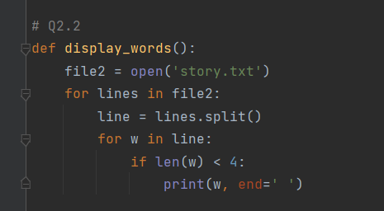

**Q3.** **(2.5 marks). Write a program that performs the following tasks:**

1. Write a function in Python to count uppercase characters in a text file.

**Expected Output:**



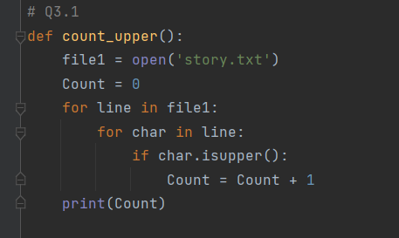

1. Write a function in Python to count the words "this" and "these" present in a text file "article.txt". [Note that the words "this" and "these" are complete words]

**Expected Output:**



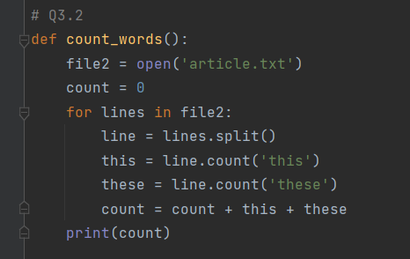

**Q4. (2.5 marks). Write a program that performs the following tasks:**

Write a program to create a dictionary to translate English into Vietnamese for 15 pets in the house, then write this dictionary to the animal.txt file.

